1° vague :

|  |  |  |  |  |  |  |  |  |  |
| --- | --- | --- | --- | --- | --- | --- | --- | --- | --- |
| Elève | poteau | poinçon | arbaL | coyau | ½ entrait OUS | ½ entrait  US | entrait  OUS | entrait  US | contreF |
| ***quantité*** | ***4*** | ***1*** | ***4*** | ***4*** | ***2*** | ***2*** | ***1*** | ***1*** | ***4*** |
| BARET  Yoann | **x** |  |  |  | **x** |  |  |  |  |
| BOUCHER Arthur |  |  |  | **x** |  | **x** |  |  |  |
| DURAND  Alexis |  | **x** | **x** |  |  |  |  |  |  |
| FLACHER Benjamin |  |  | **x** |  | **x** |  |  |  |  |
| GHIRARDI Kévin | **x** |  |  |  |  | **x** | **X** |  |  |
| HANAI  Olivier |  |  |  | **x** |  |  |  |  |  |
| LAPORTE Mayrig | **x** |  | **x** |  |  |  |  | **x** |  |
| PITRUZZELLA Sébastien | **x** |  |  |  |  |  |  |  | **x** |
| PLANCON Yohann |  |  | **x** |  |  |  |  |  | **x** |
| REY  Benjamin |  |  |  | **x** |  |  |  |  |  |
| |  | | --- | | SOURNIA  Robin | |  |  |  | **x** |  |  |  |  | **x** |
| ZAPATA  Hugo |  |  |  |  |  | **x** | **x** |  | **x** |

2° vague :

|  |  |  |  |  |  |  |  |
| --- | --- | --- | --- | --- | --- | --- | --- |
| Elève | Chevron (D, G) | Empannon  (Br, Ct, Lg, My)  x (D, G) | Fourrure  (arba, coyau) | ½ panne  (B, H) | Panne brisis | Panne porteuse | Bandeau  (G, D) |
| ***quantité*** | ***4*** | ***4*** | ***4*** | ***4*** | ***4*** | ***4*** | ***4*** |
| BARET  Yoann | **X** |  |  | **X** |  | **X** |  |
| BOUCHER Arthur |  |  | **X** |  |  |  | **X** |
| DURAND  Alexis |  | **X** |  |  | **X** |  |  |
| FLACHER Benjamin | **X** |  | **X** |  |  |  | **X** |
| GHIRARDI Kévin |  |  |  | **X** |  | **X** |  |
| HANAI  Olivier |  | **X** |  |  | **X** |  | **X** |
| LAPORTE Mayrig | **X** |  |  | **X** |  |  |  |
| PITRUZZELLA Sébastien |  |  | **X** |  |  | **X** |  |
| PLANCON Yohann | **X** |  |  |  | **X** |  |  |
| REY  Benjamin |  | **X** |  | **X** |  |  | **X** |
| |  | | --- | | SOURNIA  Robin | |  |  | **X** |  |  | **X** |  |
| ZAPATA  Hugo |  | **X** |  |  | **X** |  |  |

RETOUR

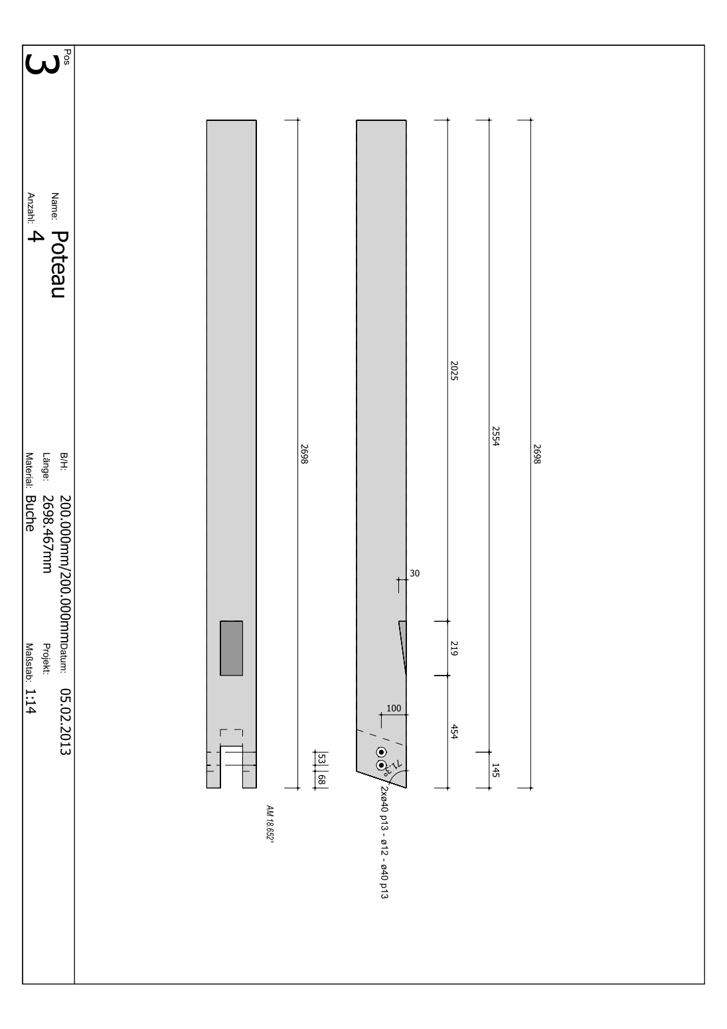

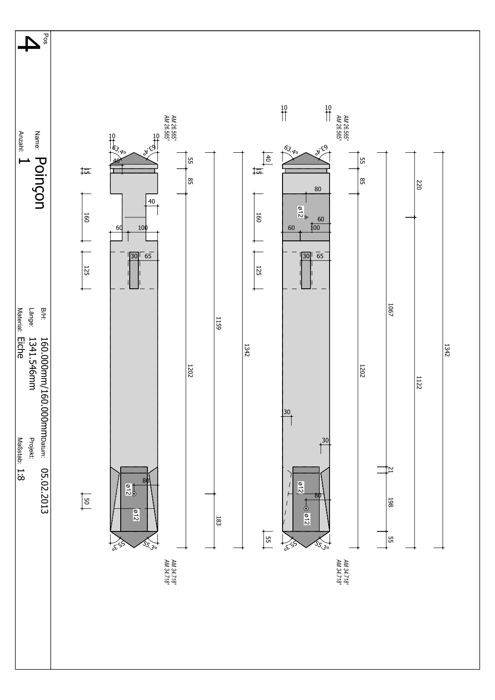RETOUR

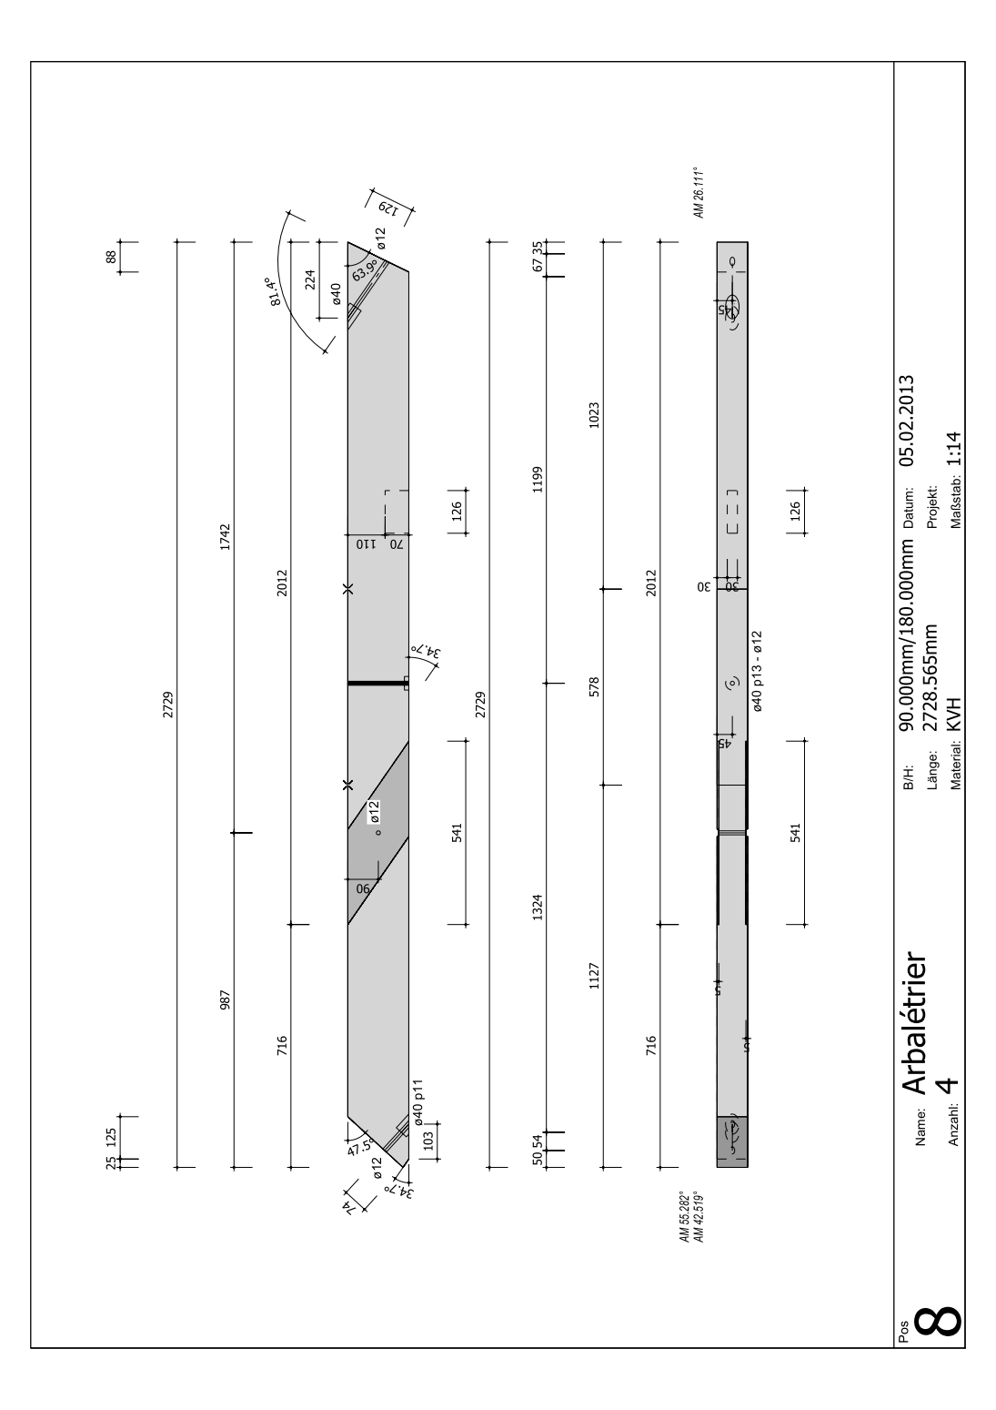RETOUR

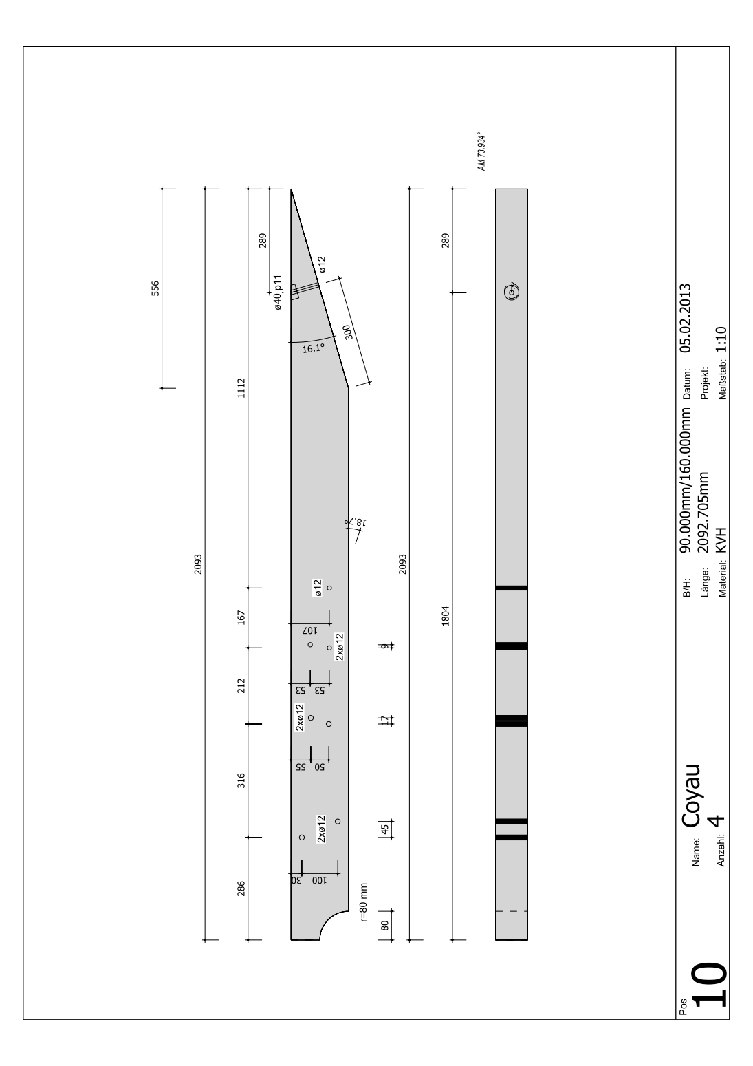

RETOUR

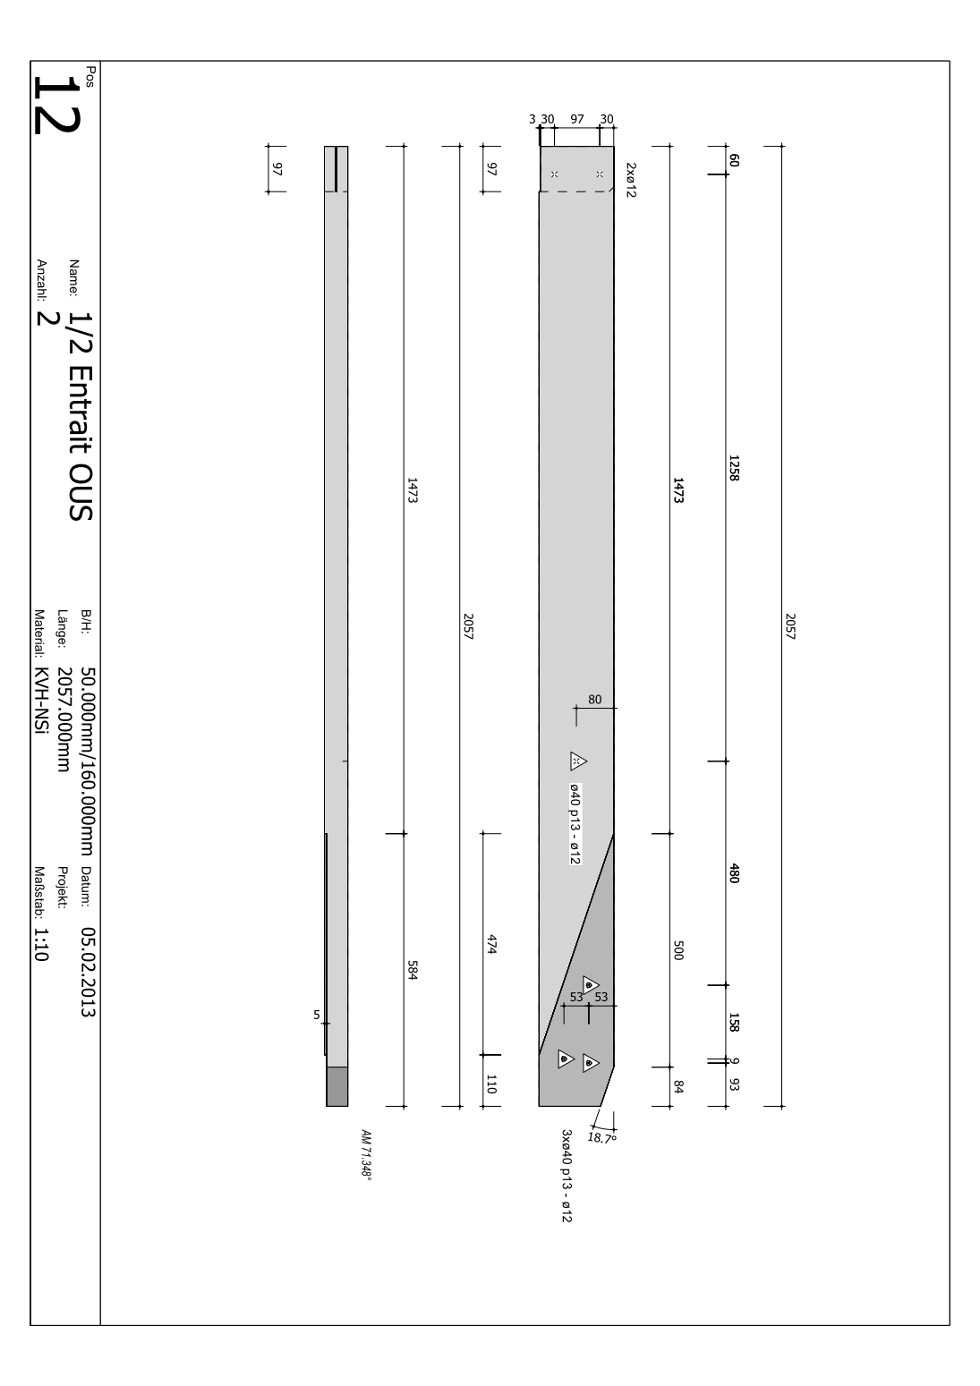

RETOUR

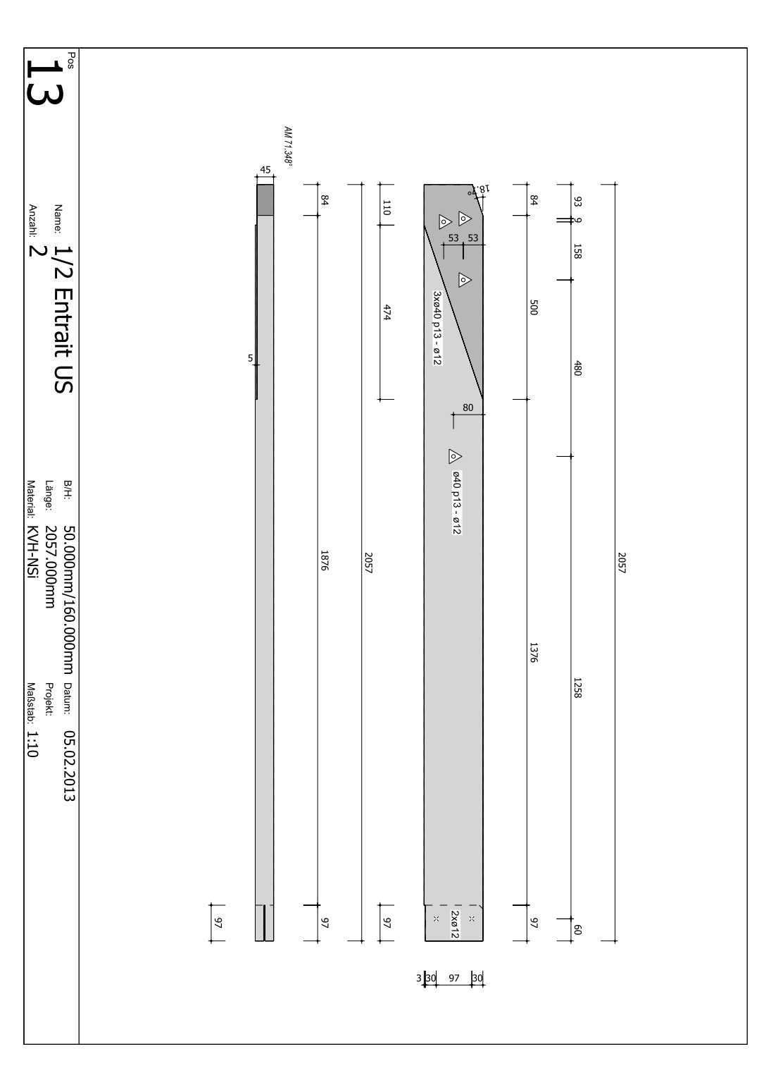

RETOUR

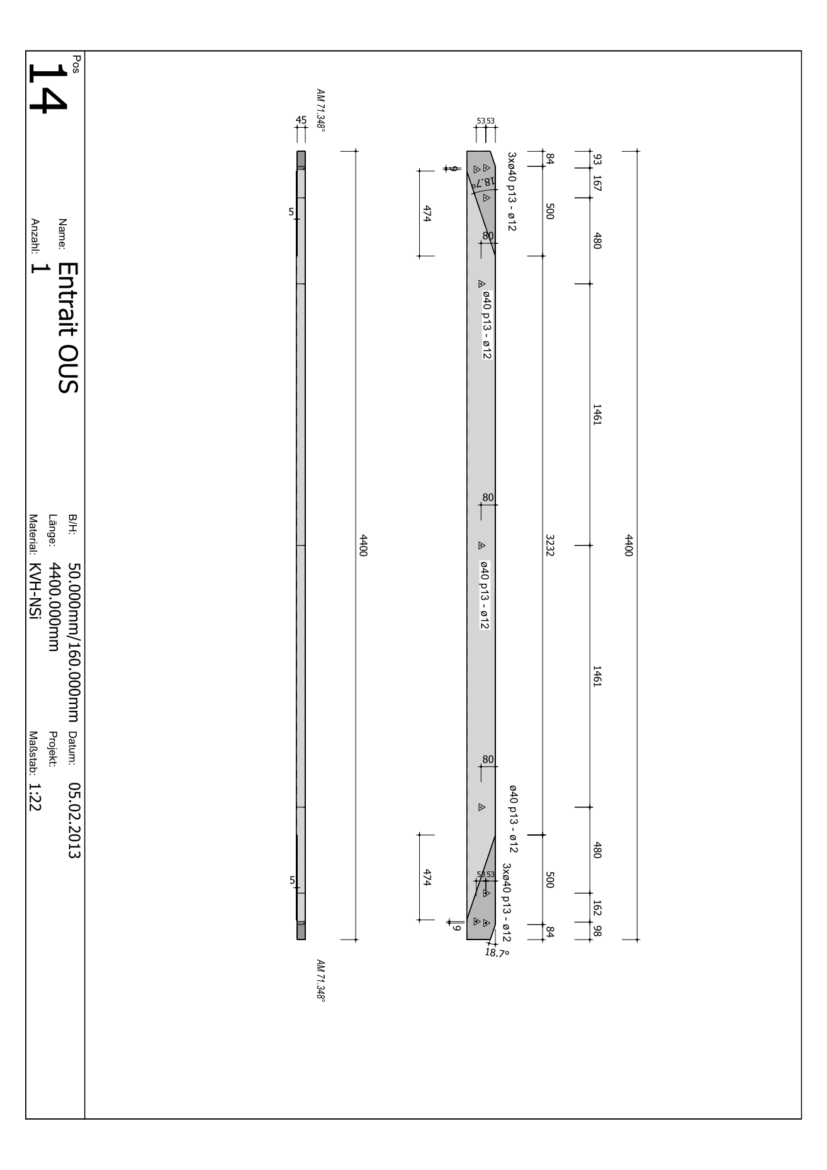

RETOUR

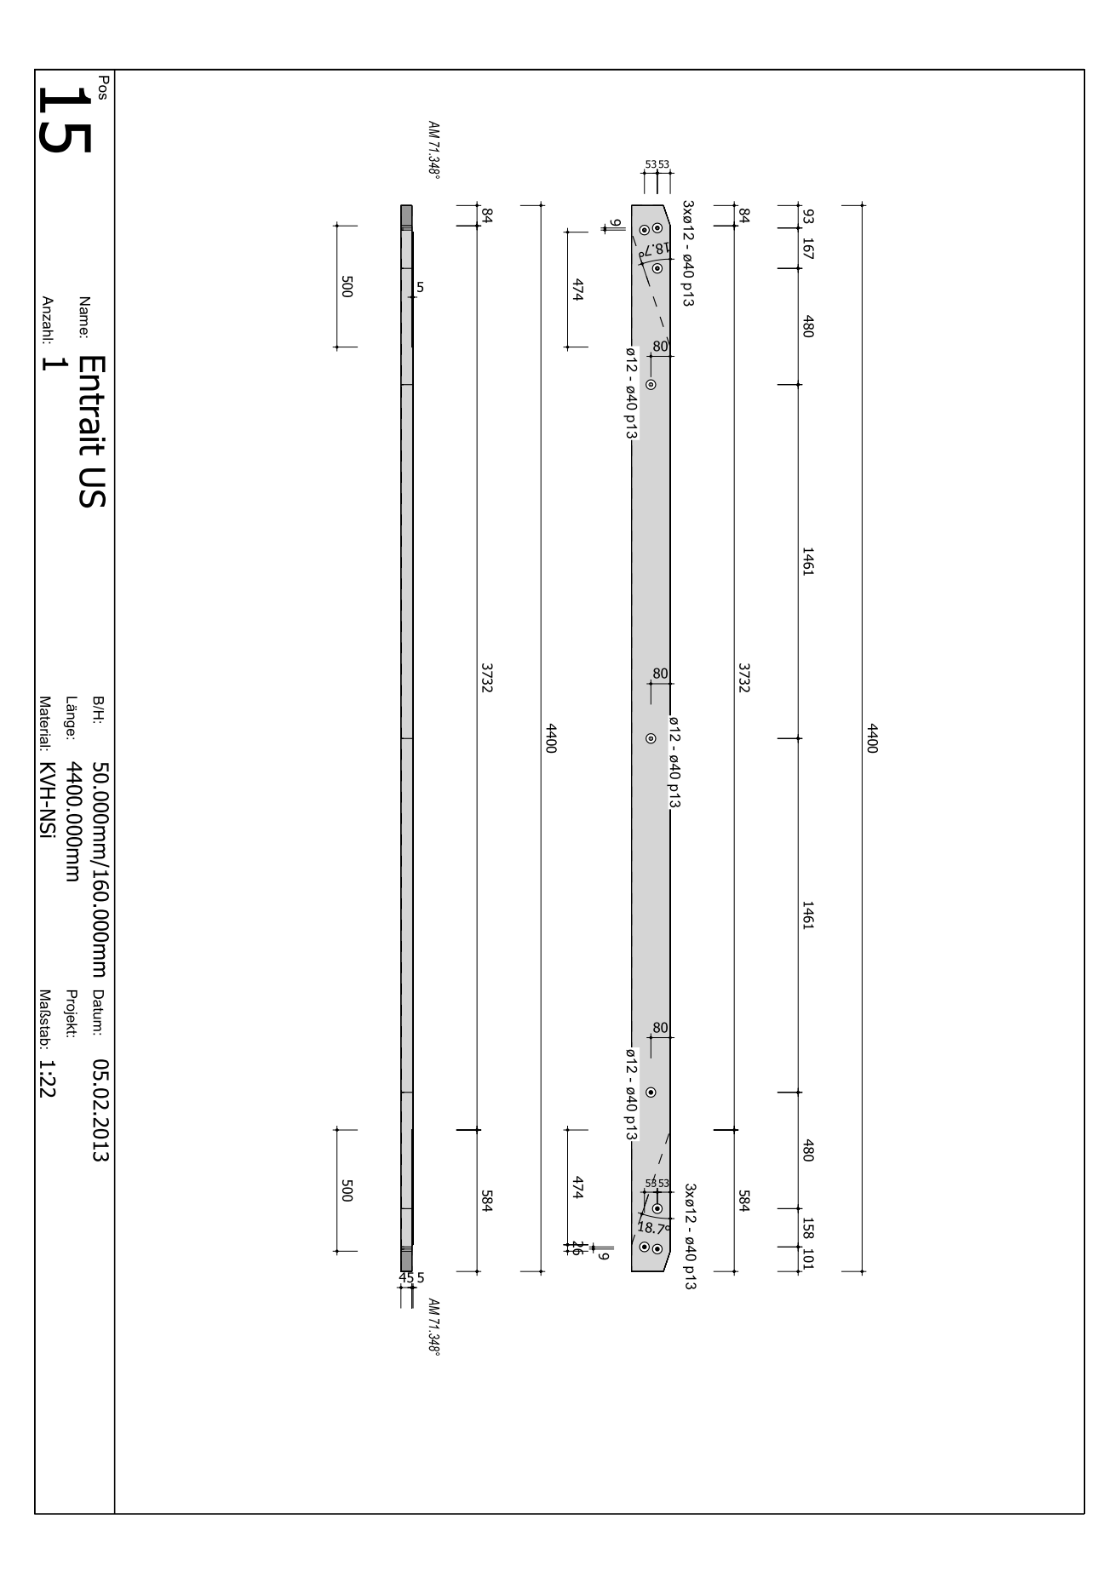

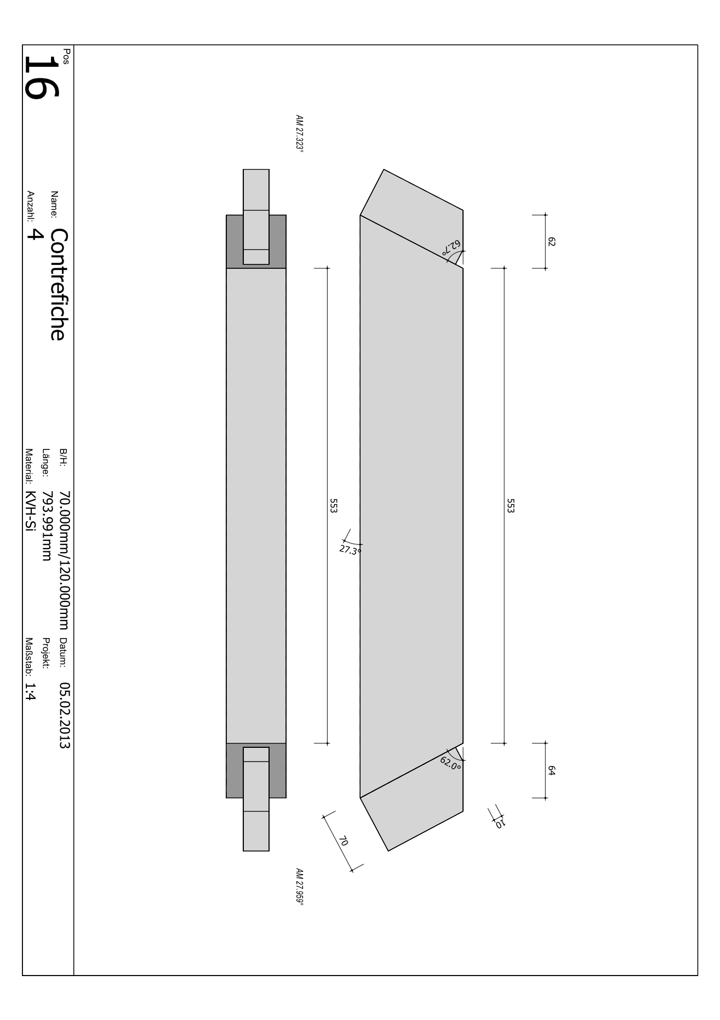RETOUR

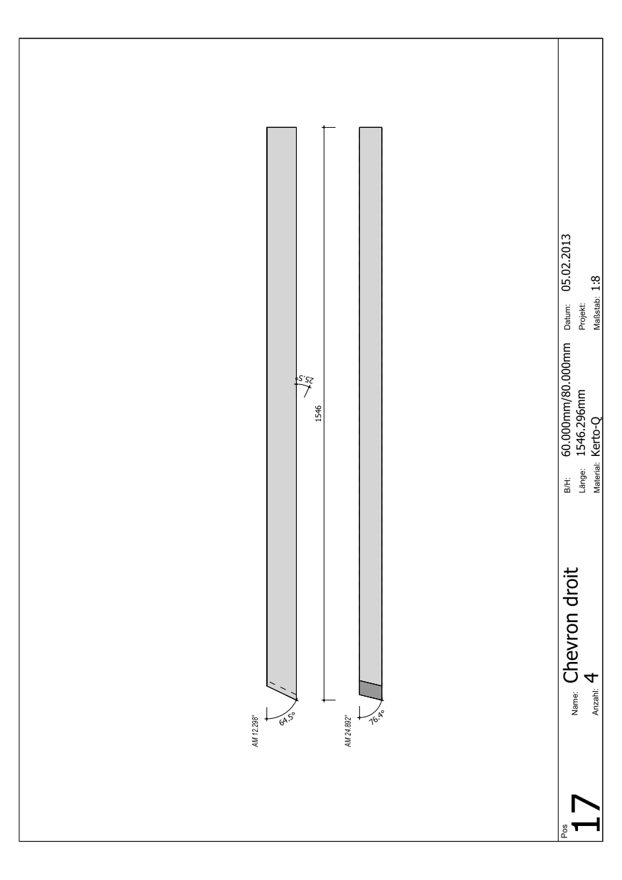RETOUR

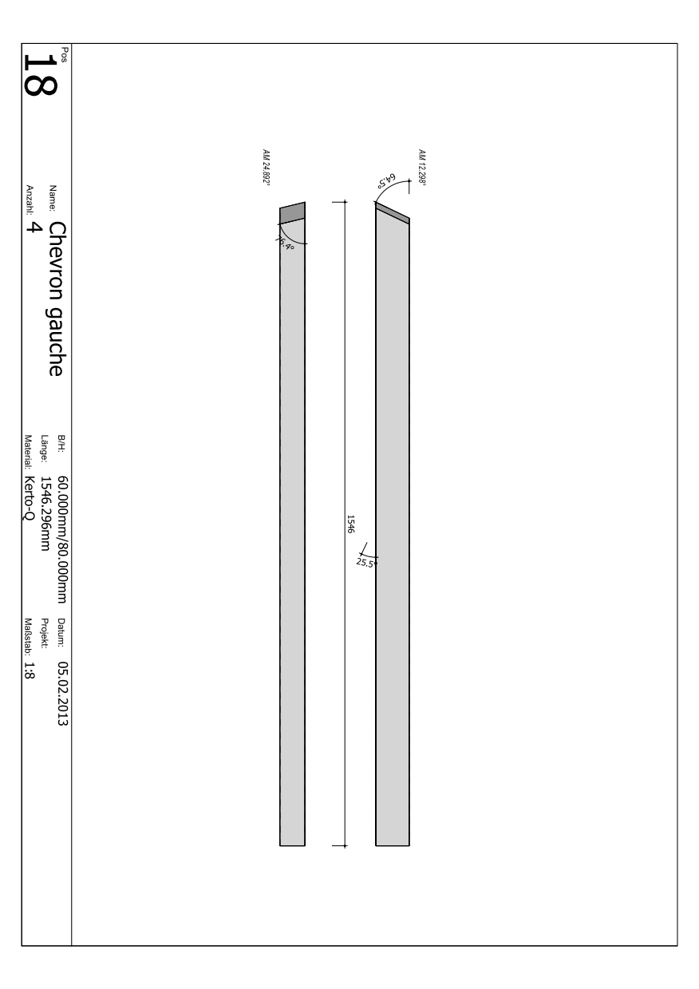RETOUR

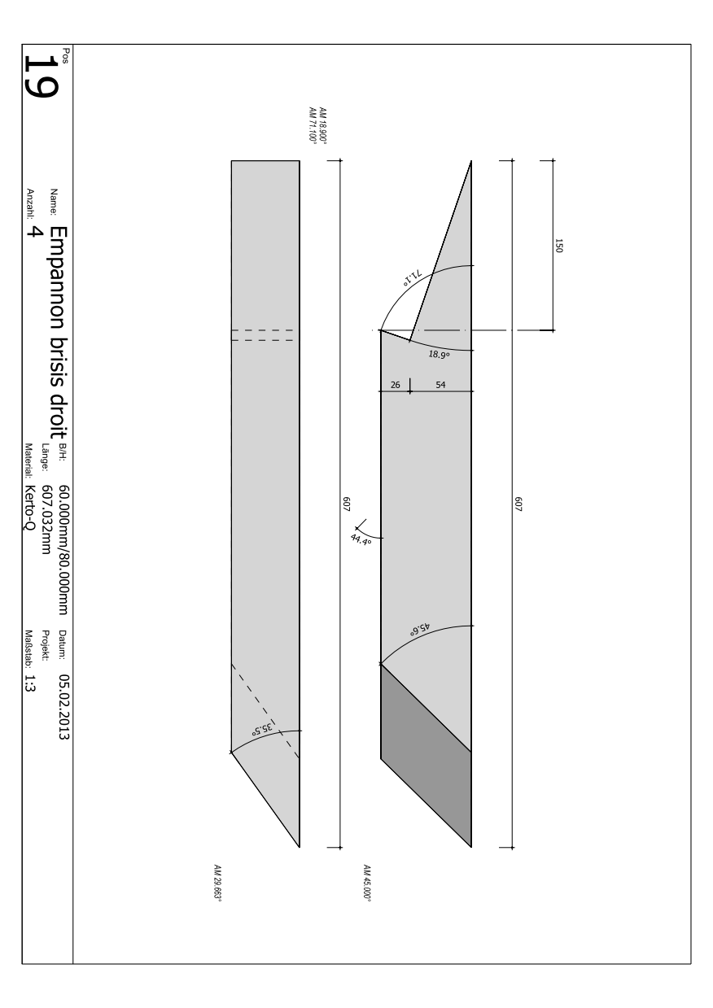RETOUR

RETOUR

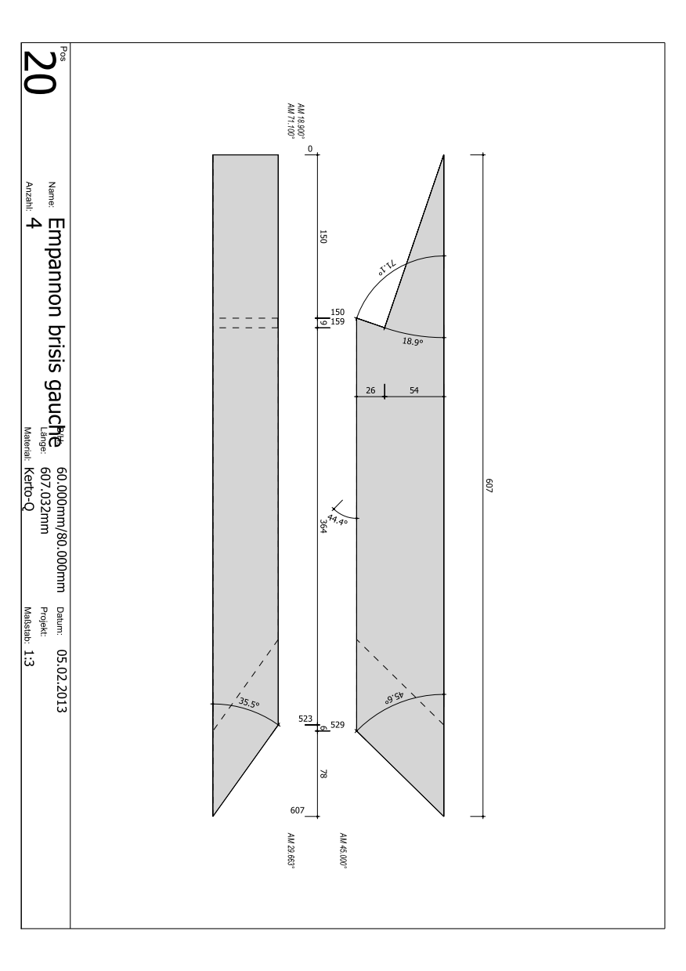

RETOUR

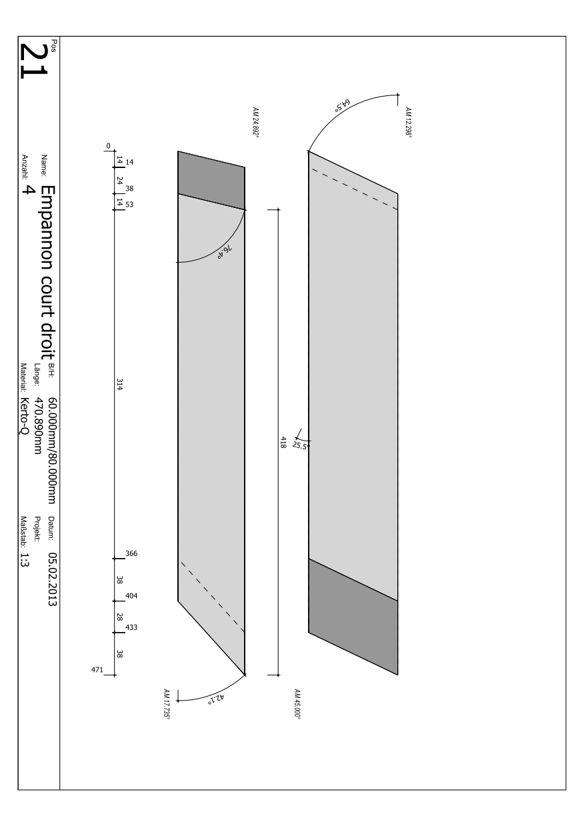

RETOUR

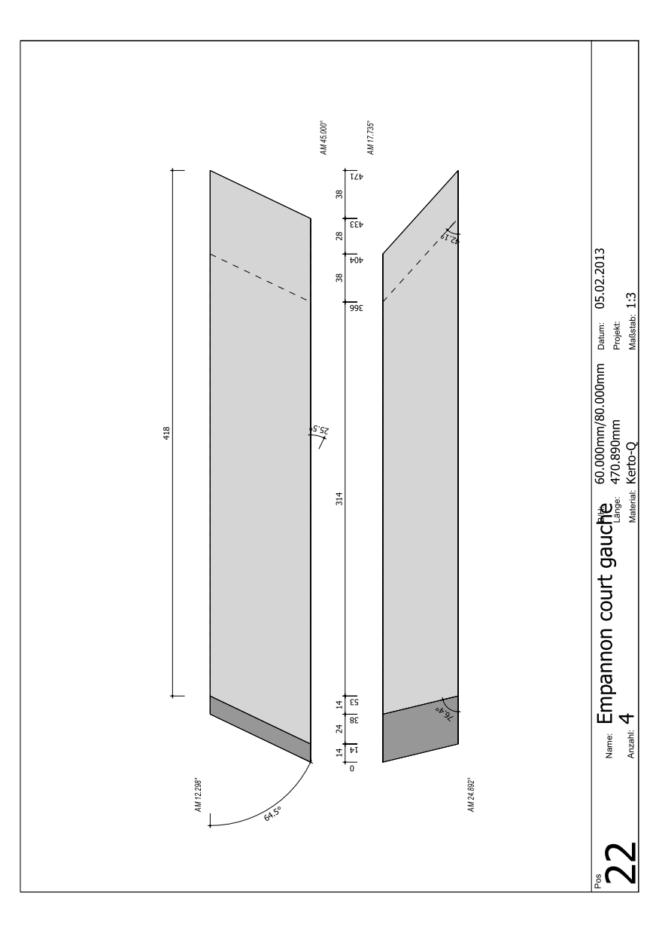

RETOUR

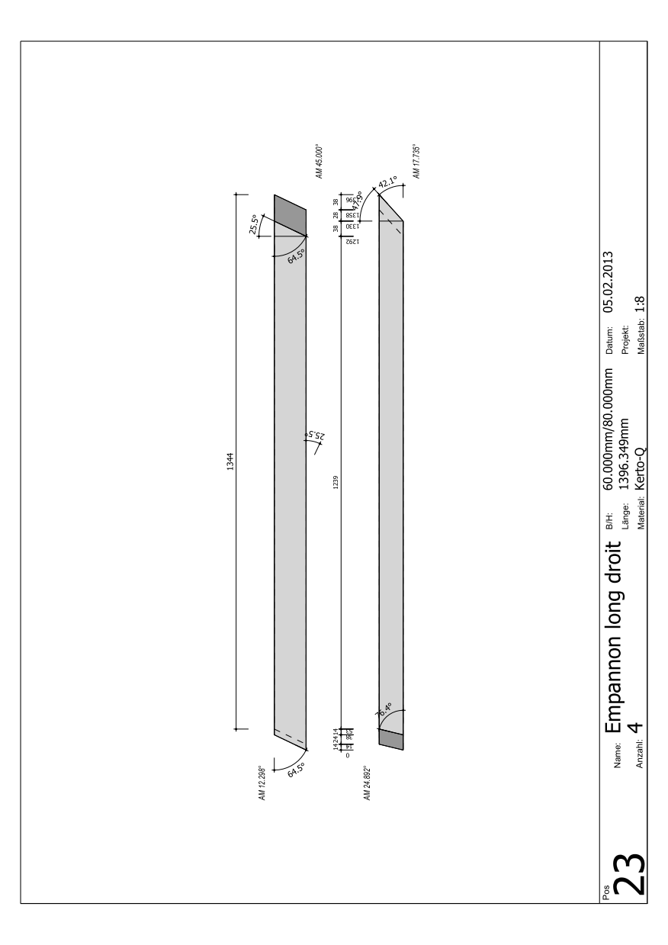

RETOUR

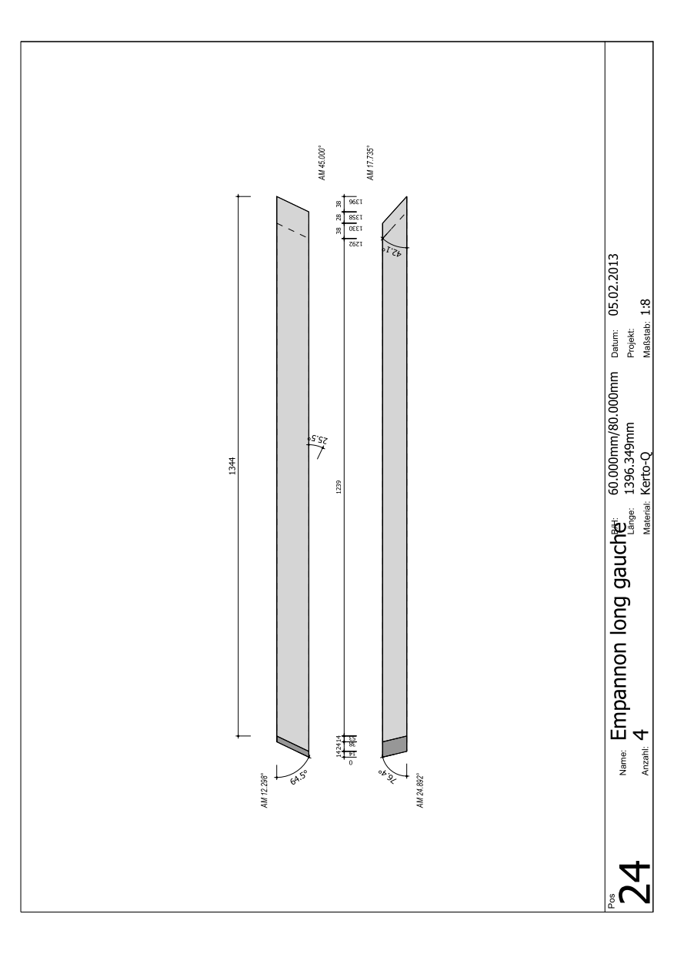

RETOUR

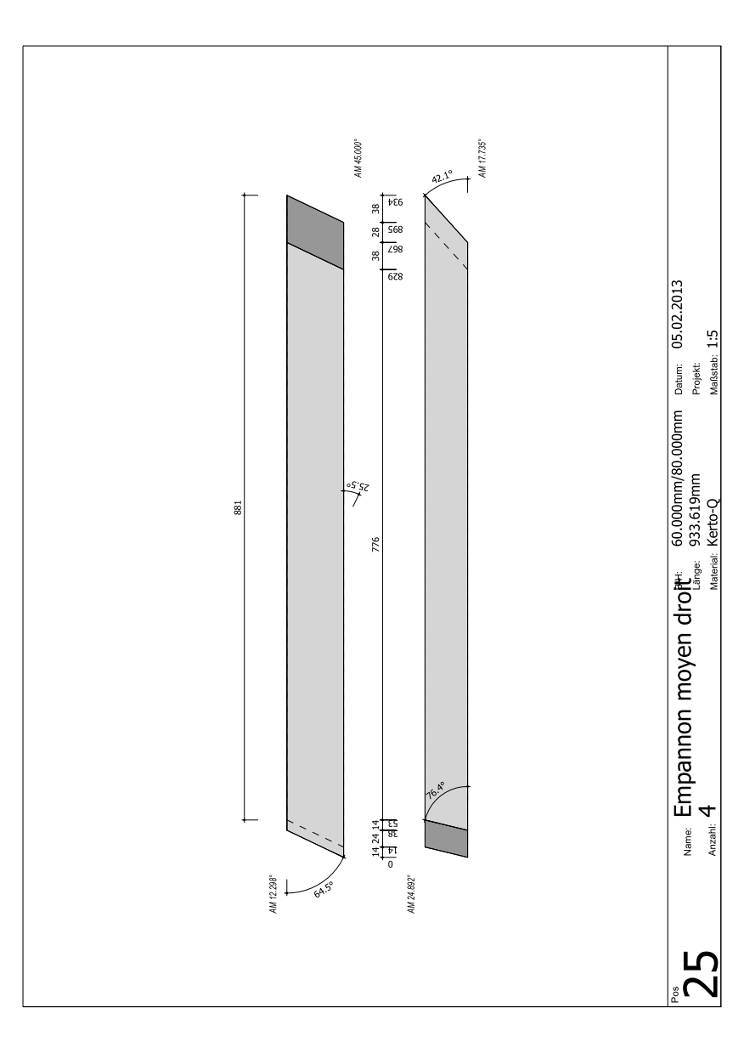

RETOUR

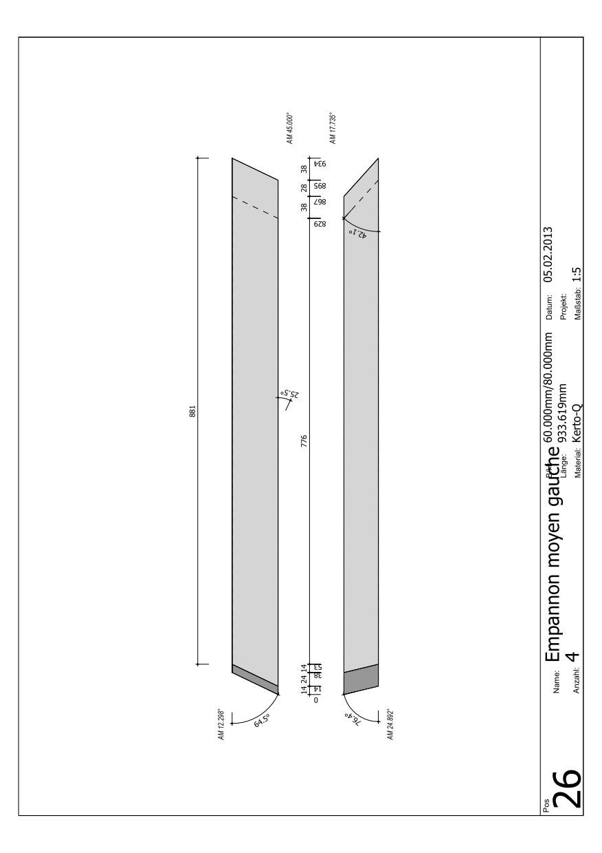

RETOUR

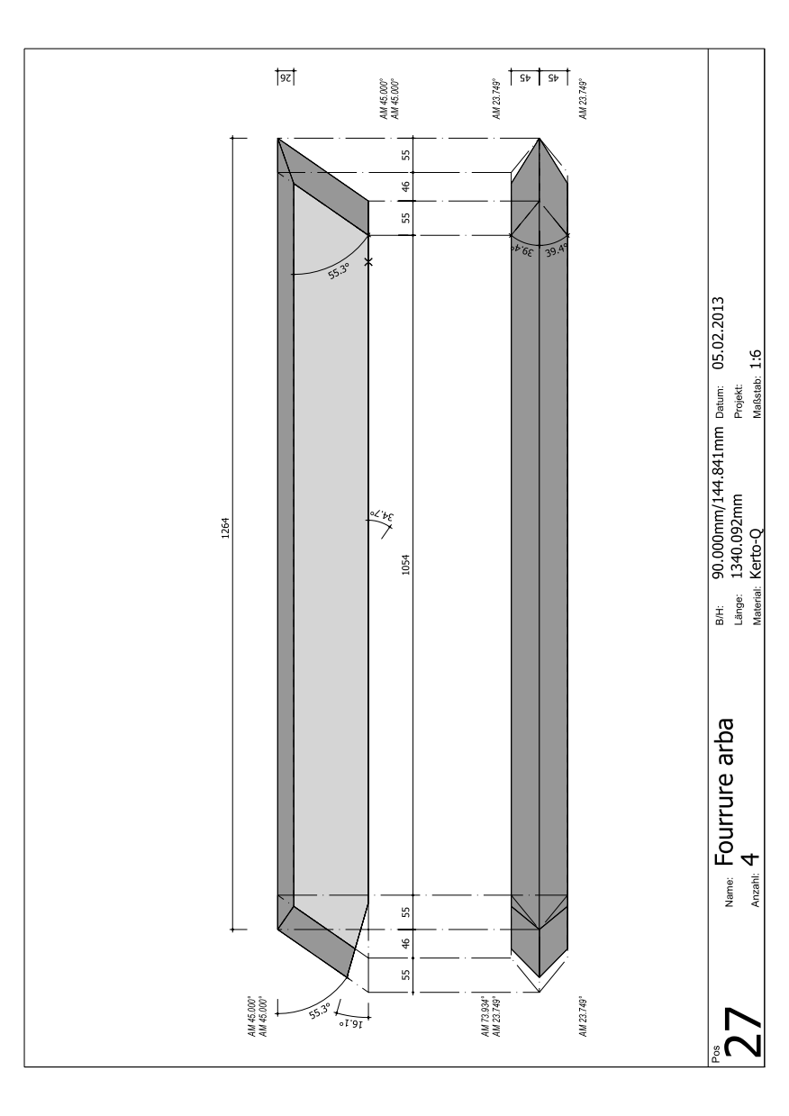

RETOUR

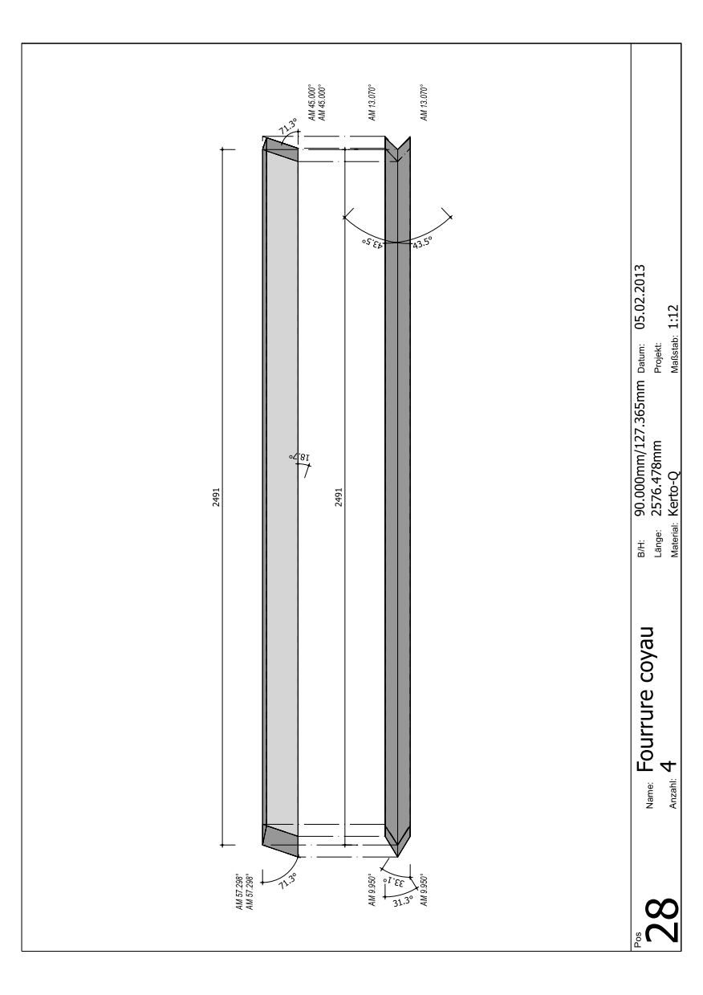

RETOUR

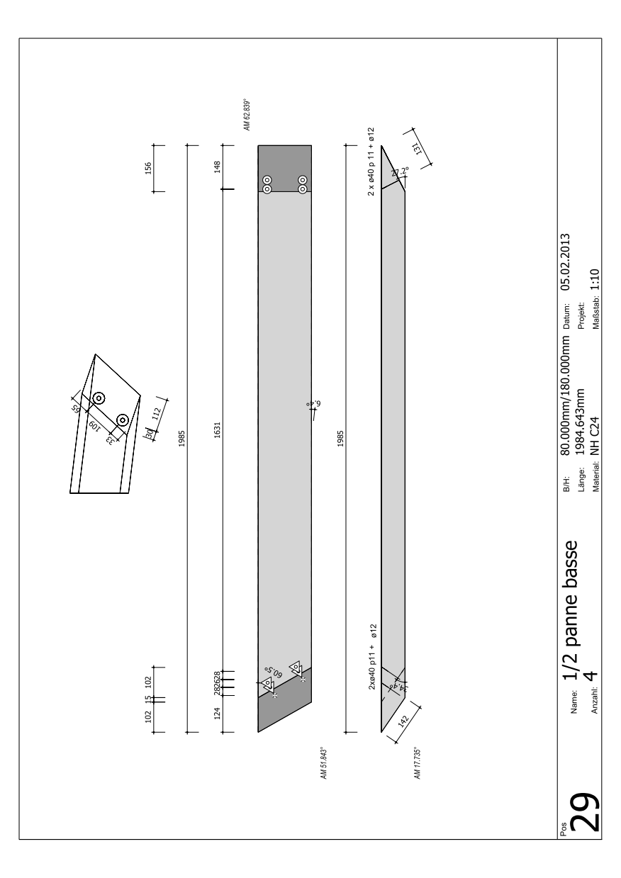

RETOUR

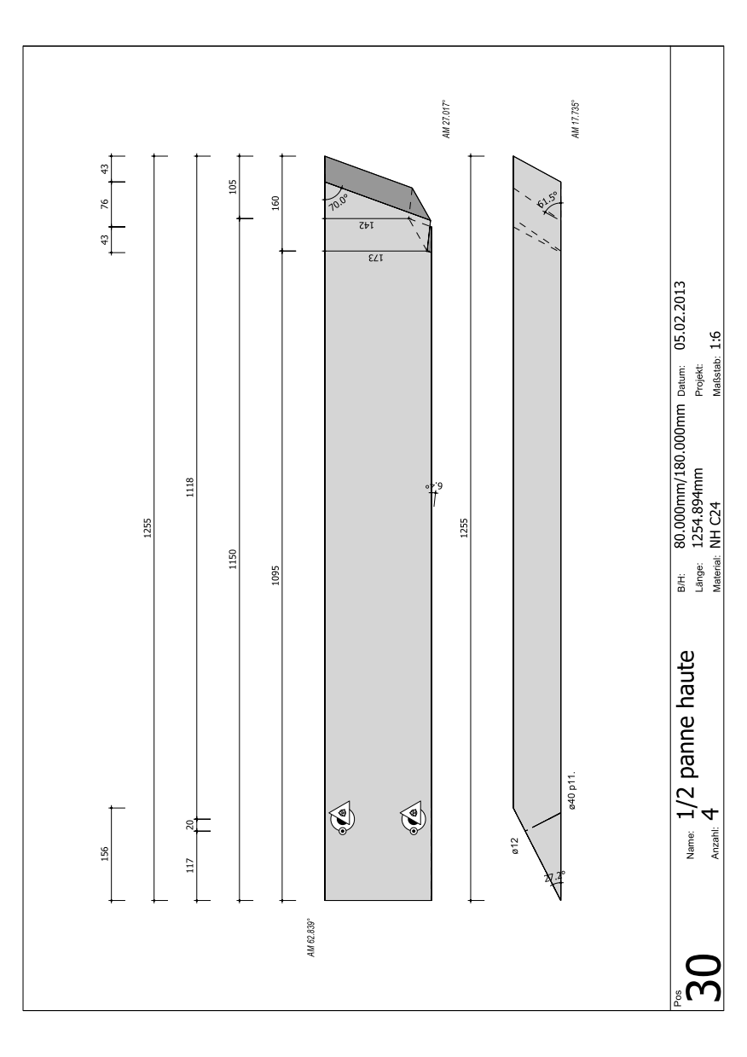

RETOUR

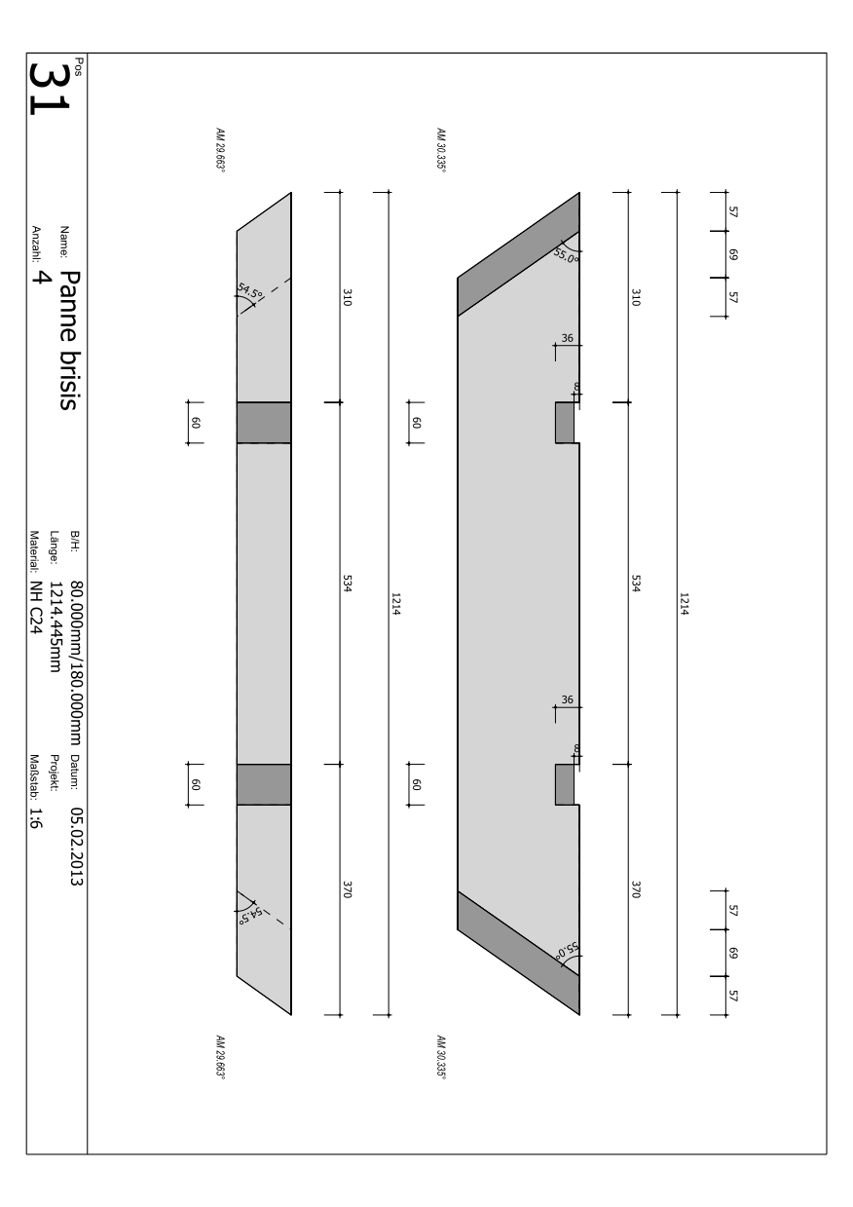

RETOUR

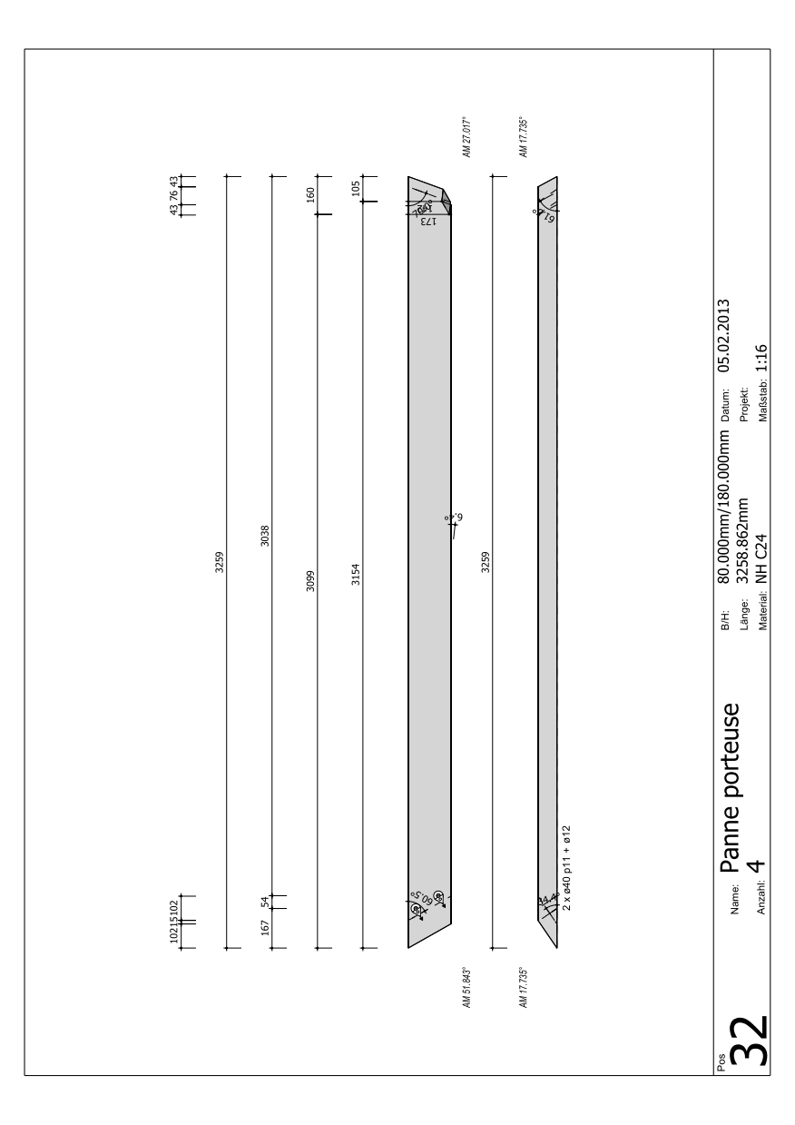

RETOUR

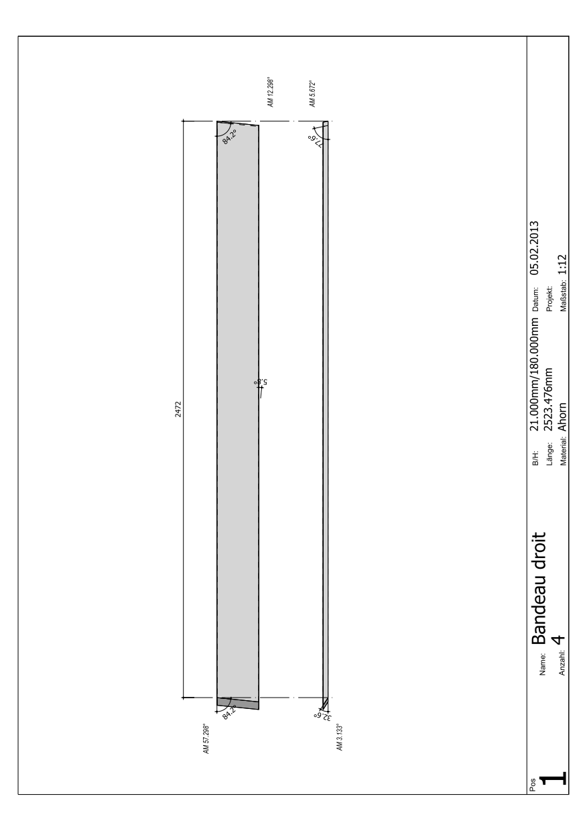

RETOUR

